**Insert School Logo**

**Semester One**

**Examination 2018**

**Question/Answer booklet**

**MATHEMATICS**

**METHODS UNIT 1**

**Section One:**

**Calculator-free**

|  |
| --- |
| Student’s Name: _____________________________________ |
| Teacher’s Name: _____________________________________ |
|  |

**Time allowed for this section**

Reading time before commencing work: five minutes

Working time for paper: fifty minutes

**Material required/recommended for this section**

**To be provided by the supervisor**

This Question/Answer booklet

Formula Sheet

**To be provided by the candidate**

Standard items: pens (blue/black preferred), pencils (including coloured), sharpener, correction tape/fluid, erasers, ruler, highlighters

Special Items: nil

**Important note to candidates**

No other items may be taken into the examination room. It is **your** responsibility to ensure that you do not have any unauthorised notes or other items of a non-personal nature in the examination room. If you have any unauthorised material with you, hand it to the supervisor **before** reading any further.

**Structure of this paper**

|  |  |  |  |  |  |
| --- | --- | --- | --- | --- | --- |
|  | Number of questions available | Number of questions to be attempted | Working time (minutes) | Marks available | Percentage of exam |
| **Section One**  **Calculator—free** | **9** | **9** | **50** | **52** | **35** |
| Section Two  Calculator—assumed | 13 | 13 | 100 | 98 | 65 |
|  | | | | 150 | 100 |

**Instructions to candidates**

1. The rules for the conduct of Western Australian external examinations are detailed in the

*Year 12 Information Handbook 2018.* Sitting this examination implies that you agree to abide by these rules.

1. Answer the questions according to the following instructions.

**Show all your working clearly.** Your working should be in sufficient detail to allow your

answers to be checked readily and for marks to be awarded for reasoning. Incorrect answers given without supporting reasoning cannot be allocated any marks. For any question or part question worth more than two marks, valid working or justification is required to receive full marks. If you repeat an answer to any question, ensure that you cancel the answer you do not wish to have marked.

It is recommended that you **do not use pencil**, except in diagrams.

1. You must be careful to confine your responses to the specific questions asked and to follow any instructions that are specific to a particular question.
2. Spare pages are included at the end of this booklet. They can be used for planning your responses and/or as additional space if required to continue an answer.

* Planning: If you use the spare pages for planning, indicate this clearly at the top of the page.
* Continuing an answer: If you need to use the space to continue an answer, indicate in the original answer space where the answer is continued, i.e. give the page number. Fill in the number of the question that you are continuing to answer at the top of the page.

1. The Formula Sheet is **not** handed in with your Question/Answer Booklet.

# Section One: Calculator–free 35% (52 marks)

This section has **nine (9)** questions. Attempt **all** questions. Write your answers in the spaces provided.

Spare pages are included at the end of this booklet. They can be used for planning your responses and/or as additional space if required to continue an answer.

* Planning: If you use the spare pages for planning, indicate this clearly at the top of the page.
* Continuing an answer: If you need to use the space to continue an answer, indicate in the original answer space where the answer is continued, i.e. give the page number. Fill in the number of the question(s) that you are continuing to answer at the top of the page.

Working time: 50 minutes

**Question 1 (6 marks)**

Consider the function 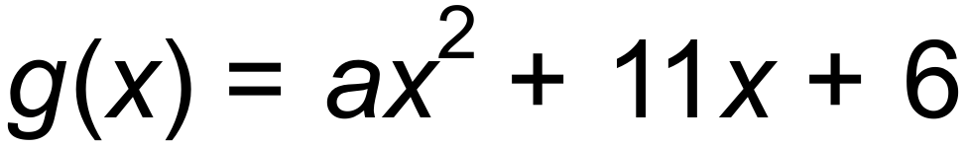 where *a* is a constant.

**(a)** (i) Given that *g*(4) = 98, evaluate *g*(−2). (2 marks)

(ii) State the equation of the axis of symmetry. (1 mark)

(iii) State the nature of the turning point. (1 mark)

**(b)** Determine all possible values of *a* given that *g*(*x*) has no real solutions. (2 marks)

**Question 2 (6 marks)**

**(a)** Find the equations of the relations below.

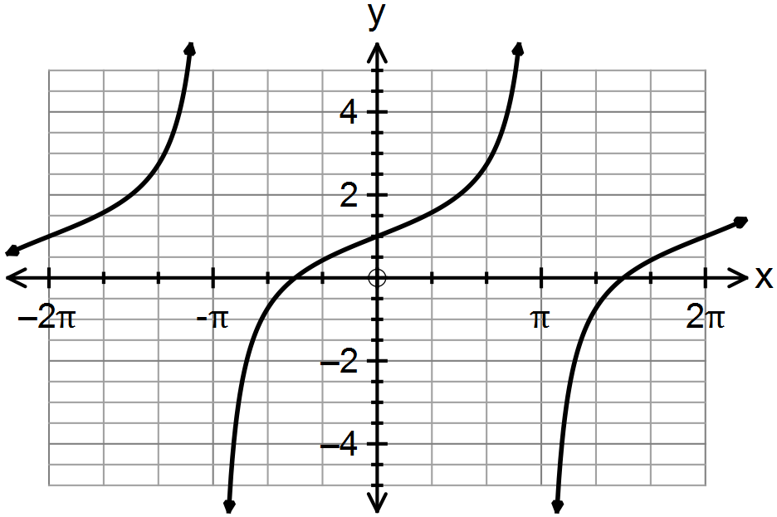 (i) (2 marks)

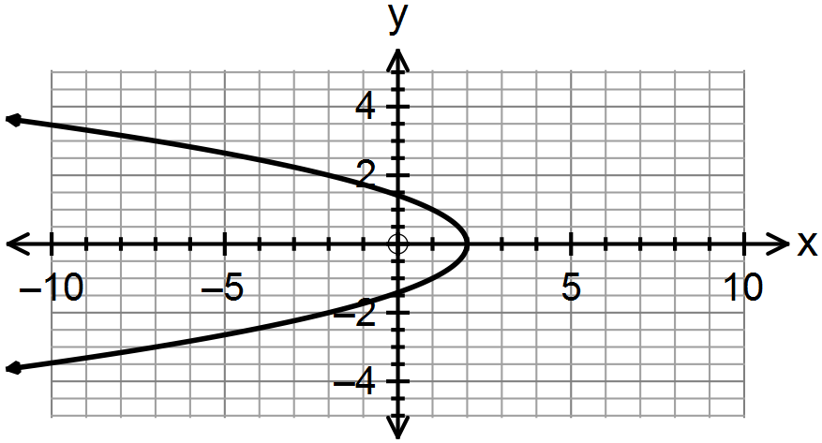(ii) (2 marks)

**(b)** Explain which of the two relations above in **(a)** is a function and why. (2 marks)

**Question 3 (6 marks)**

Line *A* and line *B* in the *xy*-plane intersect at 90° at the origin. Line *A* has a slope of 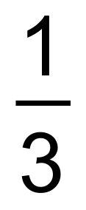 .

**(a)** Show that 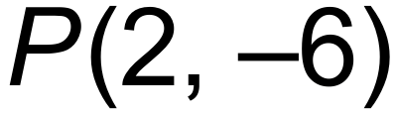 is a point on line *B.* (2 marks)

**(b)** Point  is the midpoint of line segment CD which is parallel to Line A.

Given that the x-value of C is 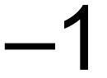, find the coordinates of point D. (4 marks)

**Question 4 (4 marks)**

**(a)** In a right triangle, one angle measures *x*°, where 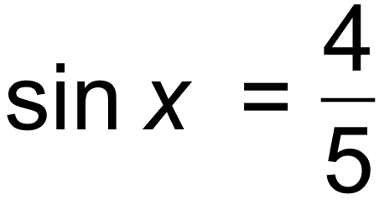.

State the value of 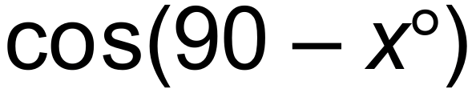. (1 mark)

**(b)** Solve the equation 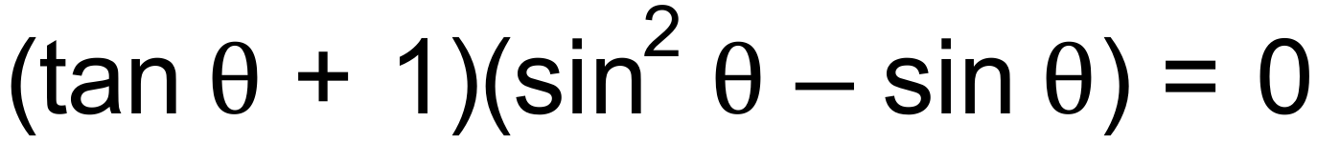 for 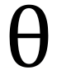, given that 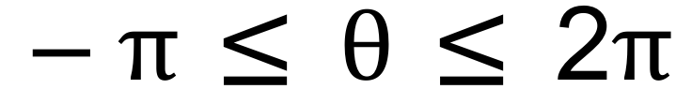. (3 marks)

**Question 5 (3 marks)**

Complete the square to find the roots of the quadratic function 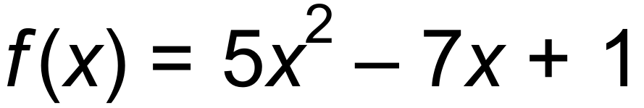. (3 marks)

**Question 6 (7 marks)**

**(a)** Sketch the curve 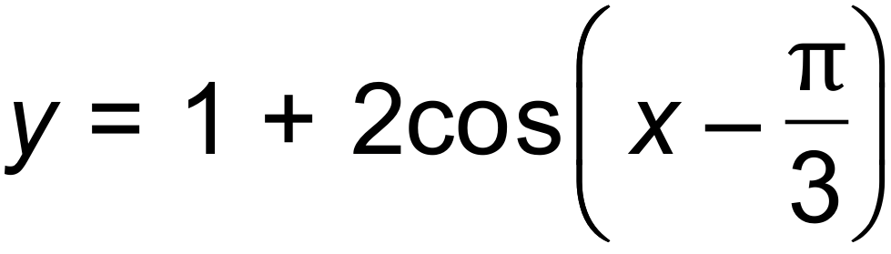 for 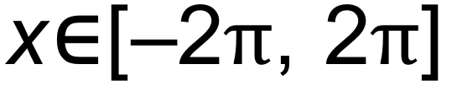 (3 marks)

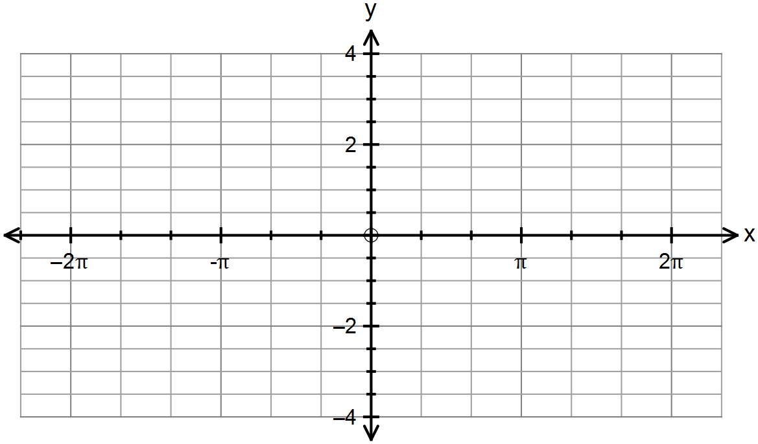

**(b)** Hence, or otherwise, solve the following equations where 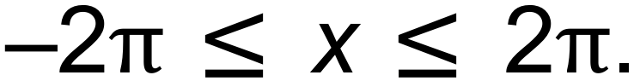

(i) 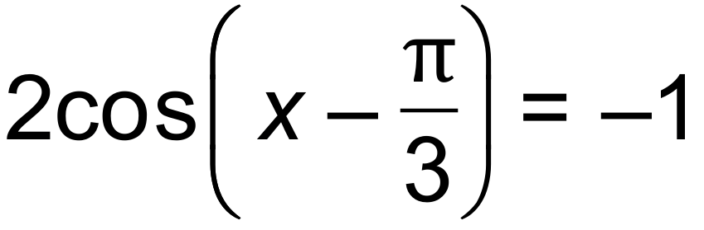 (2 marks)

(ii) 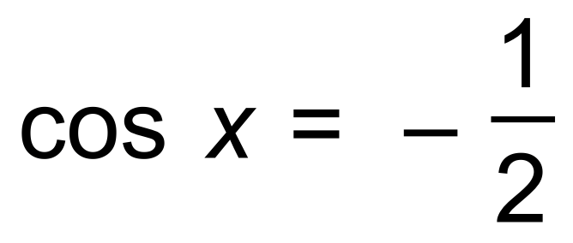 (2 marks)

(Hint: Draw the line 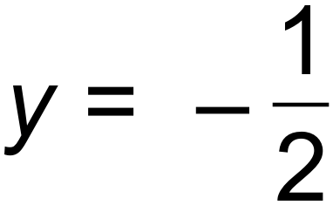 and consider the horizontal translation.)

**Question 7 (11 marks)**

**(a)** The polynomial 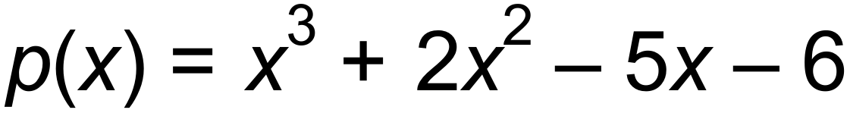 has a factor 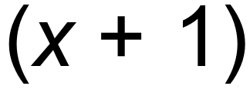.

Express 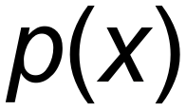 as the product of three linear factors. (3 marks)

**(b)** (i)Find the equation of the function below. (2 marks)

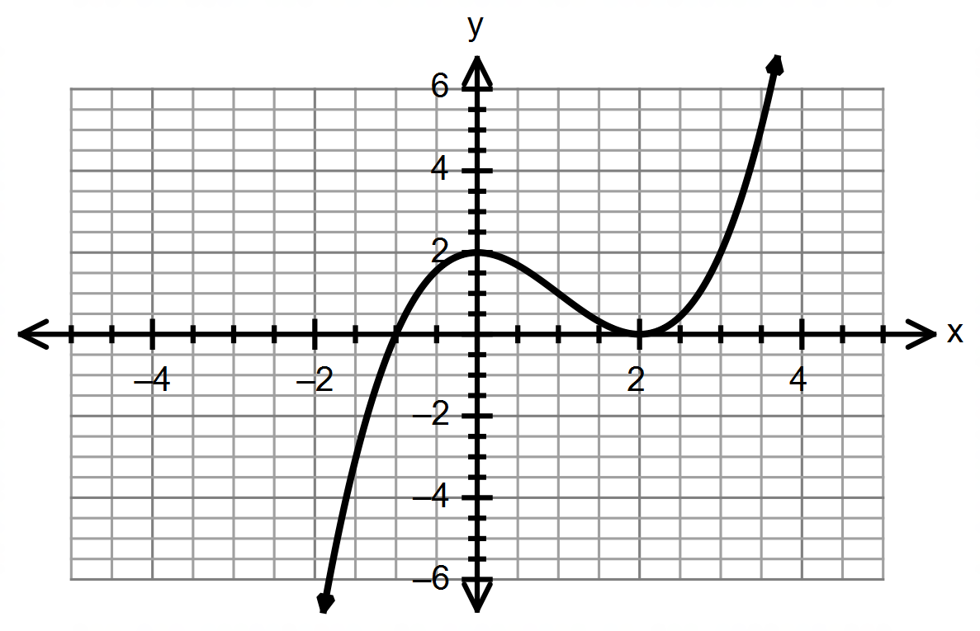

(ii) Describe the sequence of transformations that maps the graph of 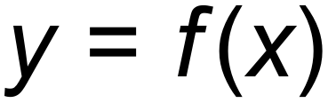 onto the graph of 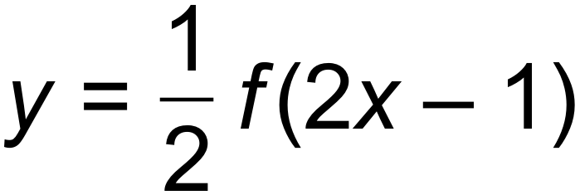. (3 marks)

(ii) The local maximum of the function  has the coordinates (0, 2).

Find the coordinates of the local maximum of the function . (1 mark)

(iii) On the same set of axes, draw the function 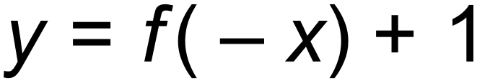 (2 marks)

**Question 8 (6 marks)**

**(a)** (i)Complete the following table of Pascal’s triangle where n = 5 and n = 6. (2 marks)

|  |  |  |  |  |  |  |  |
| --- | --- | --- | --- | --- | --- | --- | --- |
| **n** |  |  |  |  |  |  |  |
| **3** | 1 | 3 | 3 | 1 |  |  |  |
| **4** | 1 | 4 | 6 | 4 | 1 |  |  |
| **5** |  |  |  |  |  |  |  |
| **6** |  |  |  |  |  |  |  |

(ii) Hence, expand 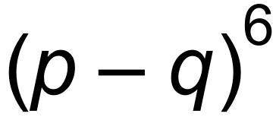 fully. (2 marks)

**(b)** Given that the 11th term in the expansion of 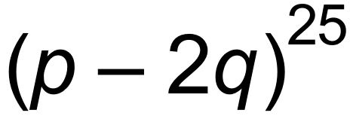 is 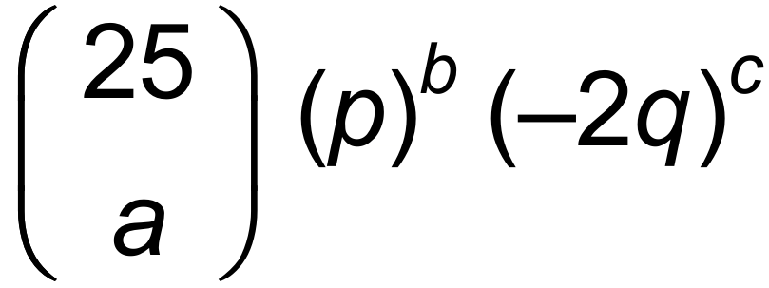, state the value of a, b and c. (2 marks)

**Question 9 (3 marks)**

By using the appropriate addition formula find the exact value of 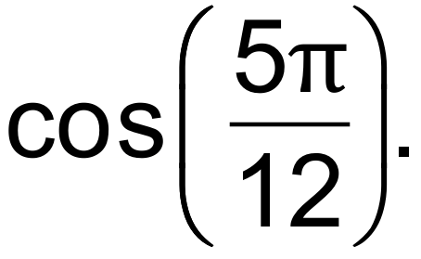 (3 marks)

**End of Questions**

**Additional working space**

Question number(s): ……………………

**Additional working space**

Question number(s): ……………………